# Test plan

**Team- Venture People**

|  |  |  |
| --- | --- | --- |
| Student Number | Name | Email |
| n11152079 | Fangdong Li | [fangdong.li@connect.qut.edu.au](mailto:fangdong.li@connect.qut.edu.au) ​ |
| n11152559 | Jianting Gao | [jianting.gao@connect.qut.edu.au](mailto:jianting.gao@connect.qut.edu.au) |
| n9541501 | Jusung Ham | [jusung.ham@connect.qut.edu.au](mailto:jusung.ham@connect.qut.edu.au) ​ |
| n10097376 | Seung-Hyuk Kim | [seunghyuk.kim@connect.qut.edu.au](mailto:seunghyuk.kim@connect.qut.edu.au) ​ |

Client: Shailesh Palekar

Tutor: Fatima Kamali

Version: 1.0

Date: 2022-10-31

Table of Contents

Test plan 1

Introduction 3

Usability test 4

Scope 4

Aim 4

Limitations 4

Test process 4

Ten principles of evaluation 5

Test Pages 6

Results 6

Tester 1 7

Tester 2 7

Conclusion 7

Unit test 8

Scope 9

Limitations 9

Test Cases 9

Module: Register 9

Module: Login 10

Module: Announcement release 11

Module: Announcement update 11

Module: Comment input 12

Conclusion 12

User acceptance test 13

Scope 14

Limitations 14

Test features 14

Must delivery features 14

Conclusion 15

References 15

Appendix-User acceptance test 16

Login 17

Log out 17

Profile setting 18

View user information 19

Release announcements 20

Delete announcements 21

Modify announcements 23

View announcements 26

Comment on announcements 26

React 27

View reactions 28

Reply to other’s comments 29

Open/close session 30

# Introduction

In order to ensure the quality of the artefact in terms of design and feature implementation, there are three tests are planned to be conducted, usability test for design; unit test and user acceptance test for feature implementation. Among them, usability test and unit test are of SHOULD priority to be executed, while user acceptance test (COULD) may not be delivered if there are any unexpected conditions.

# Usability test

## Scope

The usability test focuses on the design and usability of the artefact. In this test, there are totally two testers firstly would determine the pages to be tested based on user guide, then try to locate the shortcomings of the application in design based on Ten Principles of Nielsen Heuristic Evaluation.

## Aim

* Understand users' satisfaction with page design.
* Understand whether users can easily use the functions of the page Find the shortcomings of page functions.
* Collect user feedback on how to improve the page.
* Try to improve the usability of the page and user satisfaction.

## Limitations

This test has two obvious limitations.

First, the participants in this test are all internal personnel who have a good understanding of the project design and content, so the test results may not be objective.

Second, because the test participants are not professional testers, the test results may not be professional and comprehensive.

## Test process

1. Determine who will participate in the test (two project insiders).
2. Determine the pages and functions to be tested.
3. Each tester evaluates these pages and functions respectively and evaluates them according to ‘Nielsen's Ten Principles’.
4. Collect the evaluation of testers and summarize the feedback results.
5. Organize all feedback results into the conclusion form.

## Ten principles of evaluation

This test will be evaluated according to ‘Nielsen's Ten Principles’ (Nielsen, 1994.).

1. Visibility of system status

‘The design should always keep users informed about what is going on, through appropriate feedback within a reasonable amount of time.’

2. Match between system and the real world

‘The design should speak the users' language. Use words, phrases, and concepts familiar to the user, rather than internal jargon. Follow real-world conventions, making information appear in a natural and logical order.’

3. User control and freedom

‘Users often perform actions by mistake. They need a clearly marked "emergency exit" to leave the unwanted action without having to go through an extended process.’

4. Consistency and standards

‘Users should not have to wonder whether different words, situations, or actions mean the same thing. Follow platform and industry conventions.’

5. Error prevention

‘Good error messages are important, but the best designs carefully prevent problems from occurring in the first place. Either eliminate error-prone conditions, or check for them and present users with a confirmation option before they commit to the action.’

6. Recognition rather than recall

‘Minimize the user's memory load by making elements, actions, and options visible. The user should not have to remember information from one part of the interface to another. Information required to use the design (e.g. field labels or menu items) should be visible or easily retrievable when needed.’

7. Flexibility and efficiency of use

‘Shortcuts — hidden from novice users — may speed up the interaction for the expert user such that the design can cater to both inexperienced and experienced users. Allow users to tailor frequent actions.’

8. Aesthetic and minimalist design

‘Interfaces should not contain information that is irrelevant or rarely needed. Every extra unit of information in an interface competes with the relevant units of information and diminishes their relative visibility.’

9. Help users recognize, diagnose, and recover from errors

‘Error messages should be expressed in plain language (no error codes), precisely indicate the problem, and constructively suggest a solution.’

10. Help and documentation

‘It’s best if the system doesn’t need any additional explanation. However, it may be necessary to provide documentation to help users understand how to complete their tasks.’

## Test Pages

* Register page
* Login page
* Announcement page
* Comment page

## Results

### Tester 1

|  |  |  |  |
| --- | --- | --- | --- |
| Id | Page | Problem | Comment |
| 1 | All pages | The interface design is single and ugly | Consistency and standards |
| 2 | Login page | The picture of the page is not associated with the page theme | Aesthetic and minimalist design |
| 3 | Comment page | Didn't remind the user to post appropriate comments | Error prevention |

**Table 1-1**

### Tester 2

|  |  |  |  |
| --- | --- | --- | --- |
| Id | Page | Problem | Comment |
| 1 | All except for the Admin | All the pages are too ugly and inconsistent. | Consistency and standards |
| 2 | Login | Missing status notification | Visibility of system status |
| 3 | Comment | The Enable function needed to be click and refresh the page that can be used and lose the function after writing a new comment. | User control and freedom |
| 4 | All | There is no error notification. | Help users recognize, diagnose, and recover from errors |

**Table 1-2**

## Conclusion

|  |  |  |  |
| --- | --- | --- | --- |
| Id | Page | Problem | Comment |
| 1 | All | All the pages are too ugly and inconsistent. | Consistency and standards |
| 2 | Login | The picture of the page is not associated with the page theme | Aesthetic and minimalist design |
| 3 | Login | Missing status notification | Visibility of system status |
| 4 | Comment | The Enable function needed to be click and refresh the page that can be used and lose the function after writing a new comment. | User control and freedom |
| 5 | Comment | Didn't remind the user to post appropriate comments | Error prevention |
| 6 | All | There is no error notification. | Help users recognize, diagnose, and recover from errors |

**Table 1-3**

All page designs are too simple and ugly, the page layout is very fragmented and chaotic, and the overall style is not uniform. Most of the basic functions have been implemented, but the details are not perfect. The page lacks details such as status display, error reminder and error prevention reminder, which will affect the user experience and the usability of the page.

# Unit test

## Scope

This test aims to test the modules in the application to examine whether the code structure and logic corresponding to the module are rigorous. Meanwhile, the objective is to find out the omissions of the completed modules so that maintain and update work would be easier to undertake for the future teams if needed.

## Limitations

Due to the technical difficulty constraint, the test is conducted manually which consumes human resources and time and it didn’t cover all the modules in the artefact.

## Test Cases

*Level represents for the importance, ranging from high(H), medium(M) and low(L).

### Module: Register

|  |  |  |  |  |  |  |
| --- | --- | --- | --- | --- | --- | --- |
| Id | Level | Condition | Input | Estimated output | Actual output | Result |
|  | H | Correct email address.  Correct password format.  Correct user id. | 123@163.com  123456  11123456 | Register successfully! | Sign up successfully | Pass |
|  | L | Incorrect email address.  Correct password format.  Correct user id. | 123  123456  11123457 | Register failed! | Prompt Email Format Error | Pass |
|  | L | Correct email address.  Correct password format.  Incorrect user id. | 124@163.com  123456  tex1112345 | Register failed! | Sign up successfully | Fail |
|  | L | Correct email address.  Incorrect password format.  Correct user id. | 124@163.com  1234  1112345 | Register failed! | No reaction | Pass |
|  | H | Null email address.  Correct password format.  Correct user id. | 123456  11123457 | Register failed! | No reaction | Pass |
|  | H | Correct email address.  Null password.  Correct user id. | 12345@163.com  11123457 | Register failed! | No reaction | Pass |
|  | L | Correct email address.  Correct password format.  Null user id. | 44@163.com  123456 | Register failed! | No reaction | Pass |
|  | L | Registered email address.  Correct password format.  Correct user id. | 123@163.com  123456  11123458 | Register failed! | No reaction | Pass |
|  | L | Correct email address.  Correct password format.  Registered correct user id. | 125@163.com  123456  11123456 | Register failed! | Sign up successfully | Fail |

**Table 2-1**

### Module: Login

|  |  |  |  |  |  |  |
| --- | --- | --- | --- | --- | --- | --- |
| Id | Level | Condition | Input | Estimated output | Actual output | Status |
| 1 | H | Correct email address.  Correct password. | 123@163.com  123456 | Login successfully! | Login successfully | Pass |
| 2 | H | Incorrect email address.  Correct password. | 123@  123456 | Login failed! | No reaction | Pass |
| 3 | H | Correct email address.  Incorrect password. | 123@163.com  12345 | Login failed! | No reaction | Pass |
| 4 | H | Correct email address.  Full password. | 123@163.com | Login failed! | No reaction | Pass |
| 5 | H | Full email address.  Correct password. | 123456 | Login failed! | No reaction | Pass |

**Table 2-2**

### Module: Announcement release

|  |  |  |  |  |  |  |
| --- | --- | --- | --- | --- | --- | --- |
| Id | Level | Condition | Input | Estimated output | Actual output | Status |
| 1 | H | Normal title.  Normal content.  (Admin user) | Title1  Content1 | Release successfully! | Release successfully | Pass |
| 2 | L | Null title.  Normal content.  (Admin user) | Content | Release failed! | Release successfully | Fail |
| 3 | L | Normal title.  Null content.  (Admin user) | Title | Release failed! | Release successfully | Fail |
| 4 | H | Normal title.  Normal content.  (Student user) | Title1  Content1 | Error notification! | Error notification! | Pass |

**Table 2-3**

### Module: Announcement update

|  |  |  |  |  |  |  |
| --- | --- | --- | --- | --- | --- | --- |
| Id | Level | Condition | Input | Estimated output | Actual output | Status |
| 1 | H | Normal title.  Normal content.  (Admin user) | Title1  Content1 | Release successfully! | Release successfully! | Pass |
| 2 | L | Null title.  Normal content.  (Admin user) | Content | Error notification! | Release successfully! | Fail |
| 3 | L | Normal title.  Null content.  (Admin user) | Title | Error notification! | Release successfully! | Fail |
| 4 | H | Normal title.  Normal content.  (Student user) | Title1  Content1 | Error notification! | Error notification! | Pass |

**Table 2-4**

### Module: Comment input

|  |  |  |  |  |  |  |
| --- | --- | --- | --- | --- | --- | --- |
| Id | Level | Condition | Input | Estimated output | Actual output | Status |
| 1 | H | Normal comment | Well done | Shown with time. | Comment successfully | Pass |
| 2 | H | Comment to other’s comment | Ha ha | Shown under original comment. | Comment successfully | Pass |

**Table 2-5**

## Conclusion

Most of the test cases are passed, whereas there are some areas ignored. In detail, when releasing or updating the announcement, the user can successfully publish the announcement with null contents.

Moreover, even though the user cannot register or login successfully if he/she enter the wrong information in such pages, there is no error reminder that the user may feel confused.

# User acceptance test

## Scope

The user acceptance test is designed to check if the features are implemented based on the expected criteria, as confirmed in the newest version of the User Stories and the Artifact Agreement document.

## Limitations

It is hard to apply an external test method on account of the constraints especially in time, team size, technical difficulty, thus this test is a totally in team internal test.

## Test features

### Must delivery features

Basic features that must be delivered.

|  |  |  |
| --- | --- | --- |
| Feature | Expected outcome | Result |
| Login | The user can successfully login. | Pass |
| Log out | The login user can successfully log out. | Pass |
| Profile setting | The user can set their personal profile. | Pass |
| View user information | The user can view others’ contact details. | Pass |
| Release announcements  (Teaching team only) | The Teaching Team user can release the announcement, whereas the Student user cannot. | Pass |
| Delete announcements  (Teaching team only) | The Teaching Team user can delete the released announcement, whereas the Student user cannot. | Pass |
| Modify announcements  (Teaching team only) | The Teaching Team user can update the released announcement, whereas the Student user cannot. | Pass |
| View announcements | The user can view the announcements. | Pass |
| Comment on announcements | The user can add comments to every announcement. | Pass |
| React | The user can select an emoji reaction. | Pass |
| View reactions | The user can see the emoji reactions. | Pass |
| Reply to others’ comments | The user can reply to others’ comments. | Pass |
| Delete messages | The Teaching Team can delete every comment if needed, and the Student user can only delete the comments made by himself/herself. | Pass |
| Close/close session (COULD) | The Teaching Team user can open/close a session if needed. | Pass (issue) |

**Table 3-1**

## Conclusion

To conclude, the basic functions are implemented except for the sensitive word. However, there might be errors with the Open/close session that it needed to click the button and refresh the page and repeat the operations again and again due to the limitation of Ruby itself.

# References

Nielsen. (1994). Enhancing the explanatory power of usability heuristics. *Proceedings of the SIGCHI Conference on Human Factors in Computing Systems,* 152–158. <https://doi.org/10.1145/191666.191729>

# Appendix-User acceptance test

## Login

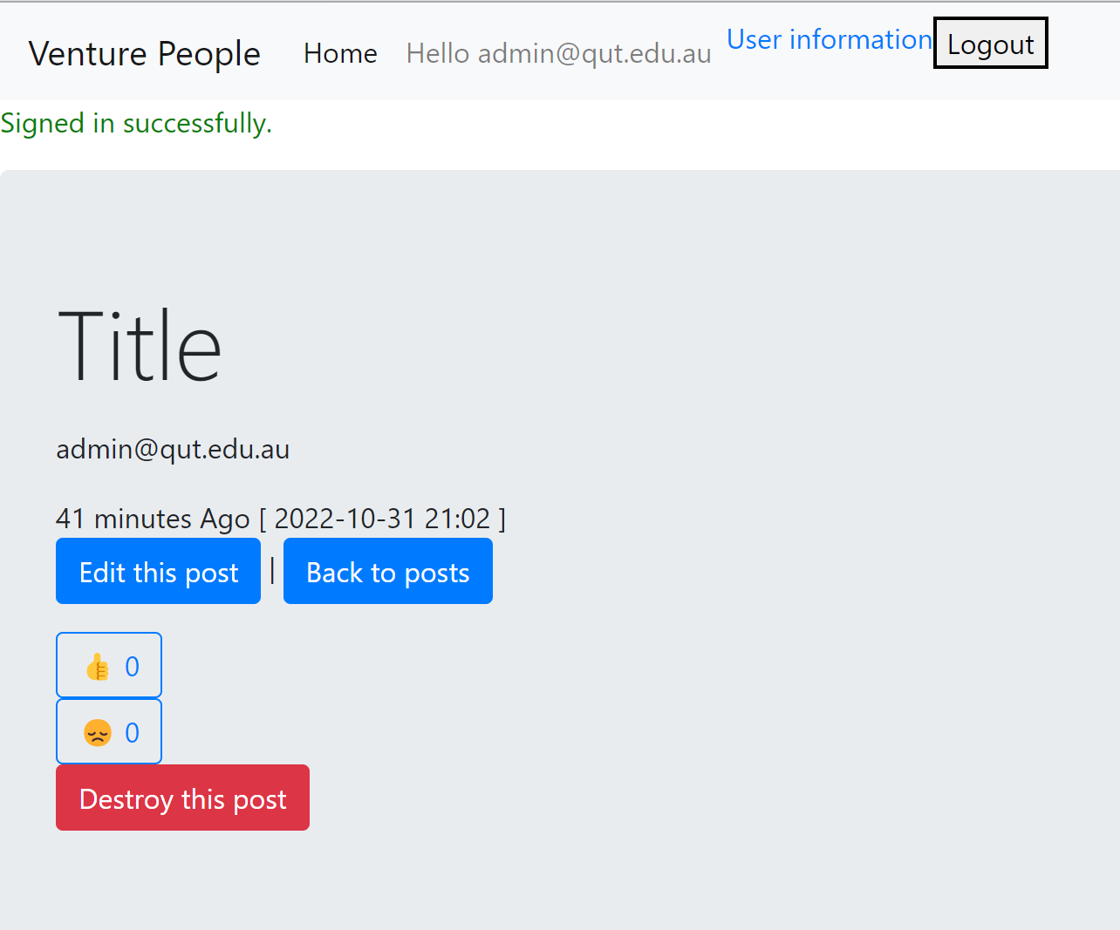

**1-1**

## Log out

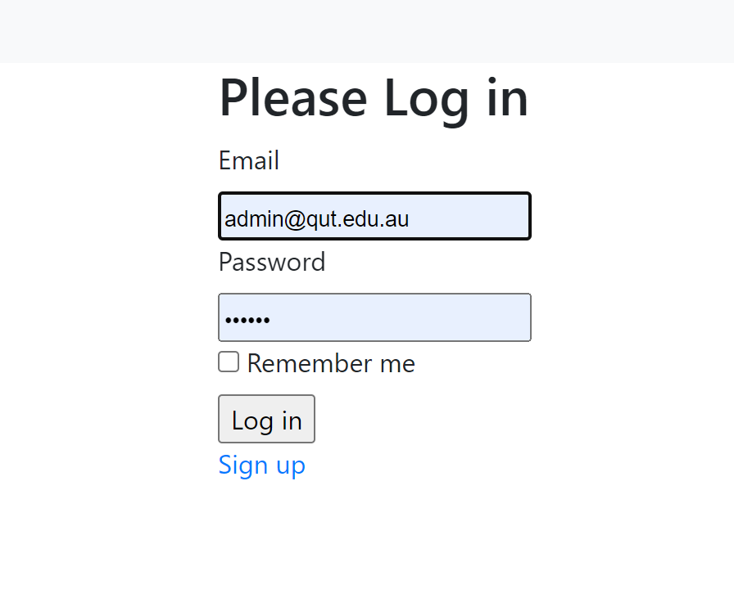

**2-1**

## Profile setting

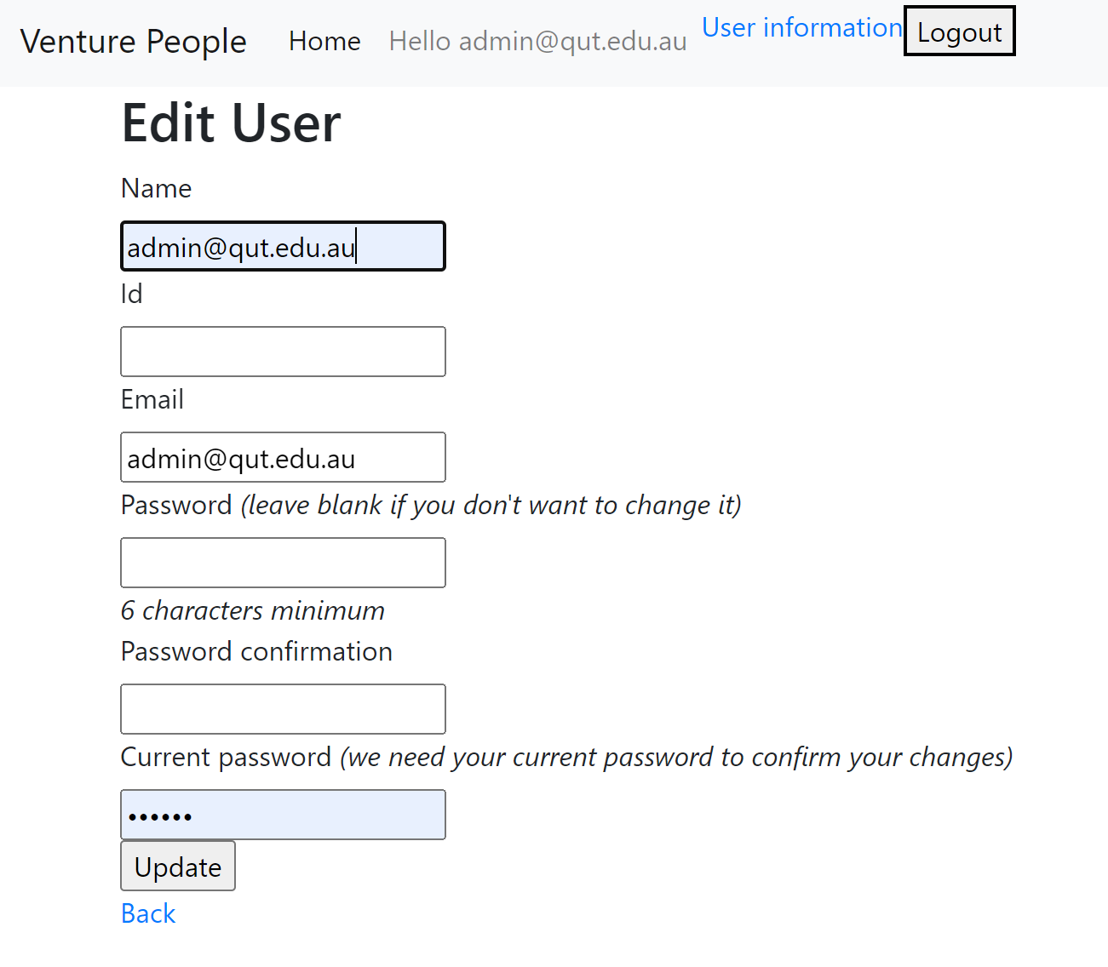

**3-1**

## View user information

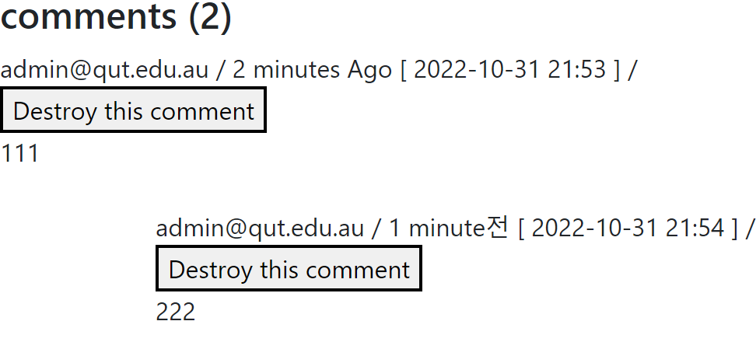

**4-1**

## Release announcements

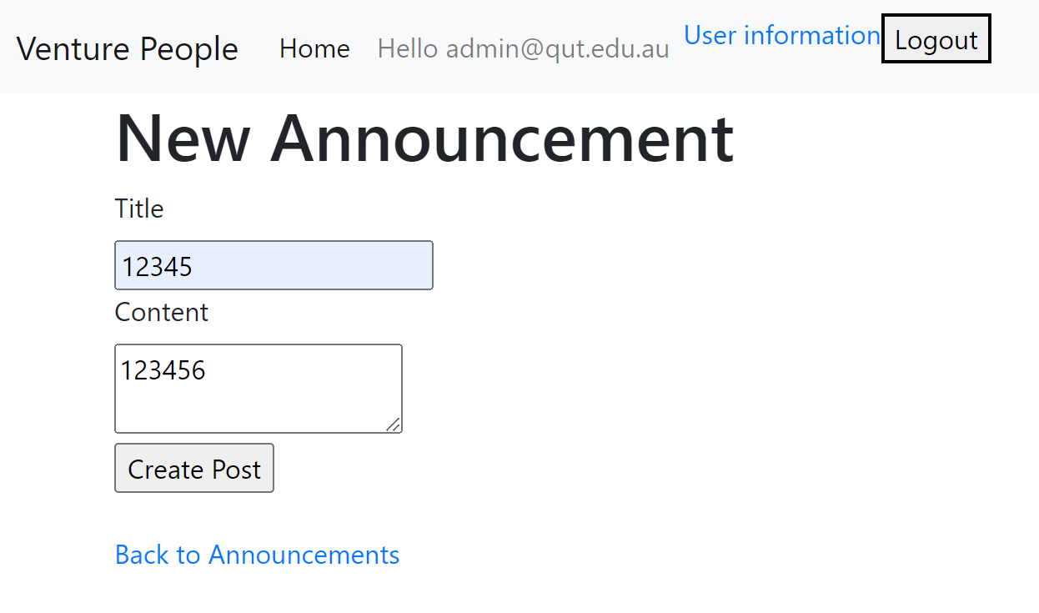

**5-1**

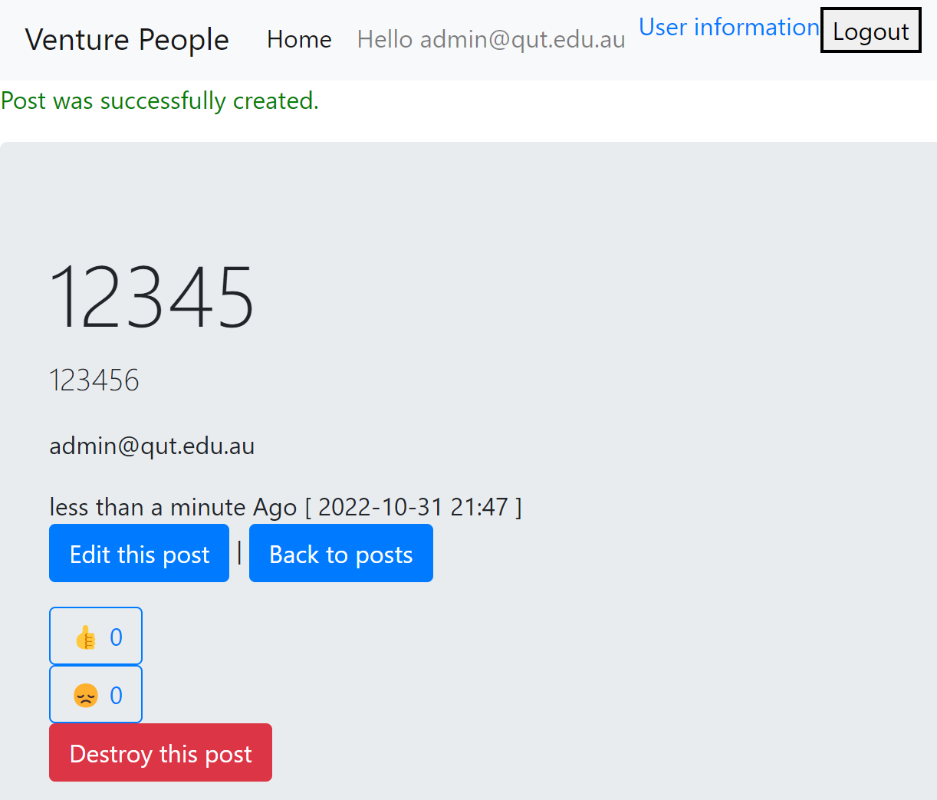

**5-2**

## Delete announcements

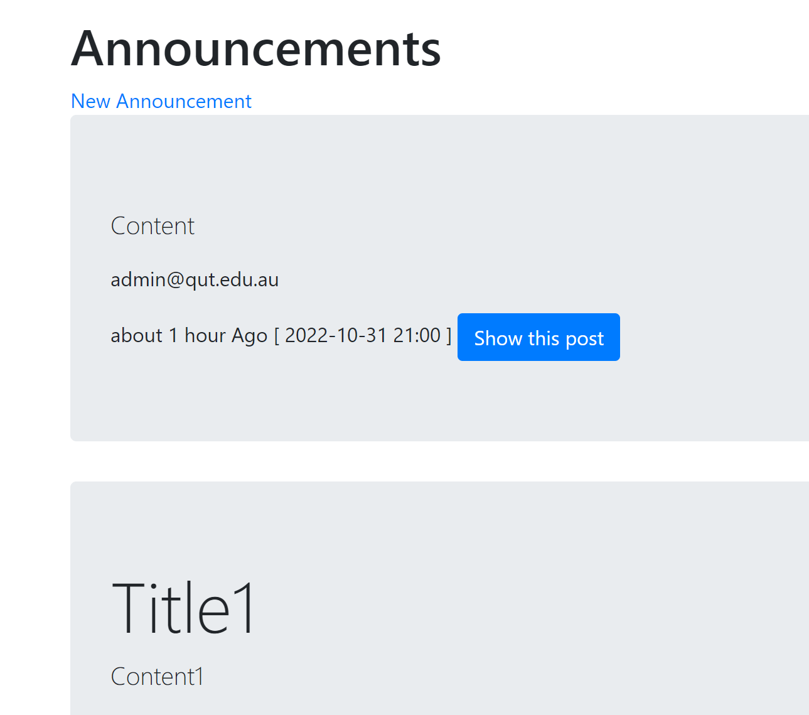

**6-1**

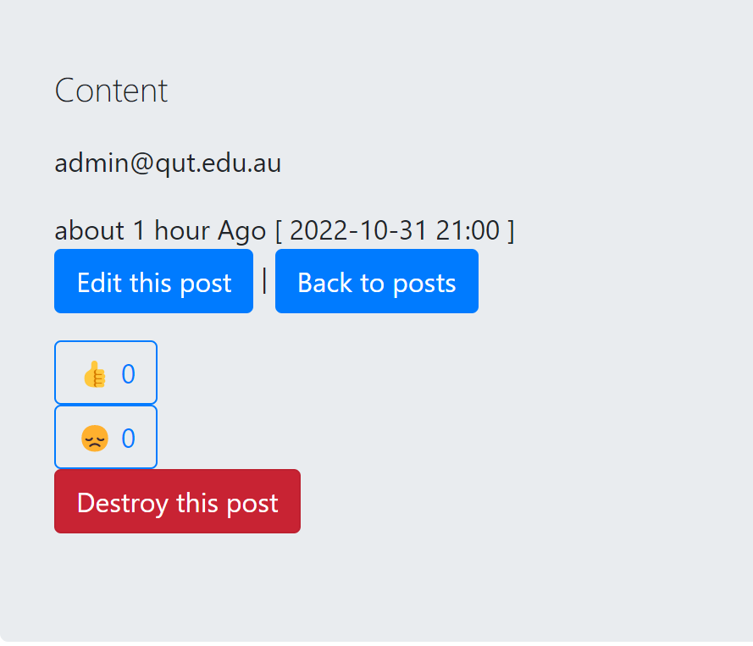

**6-2**

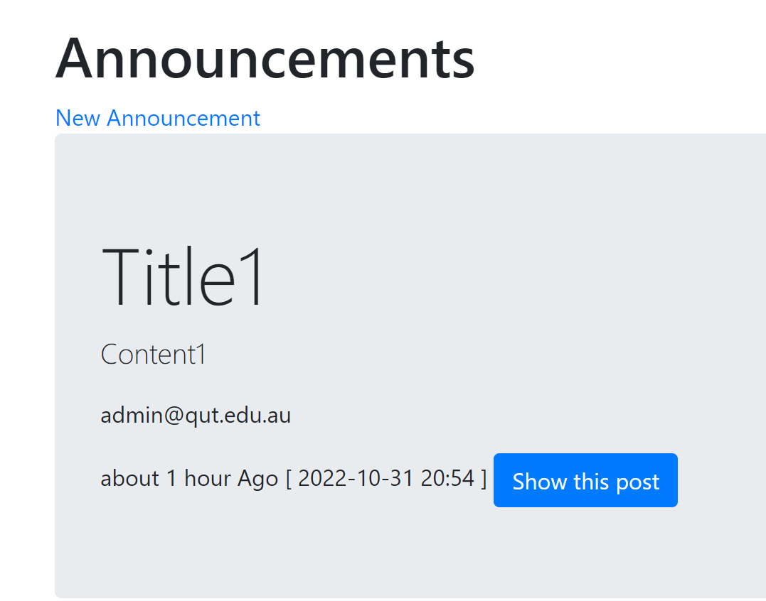

**6-3**

## Modify announcements

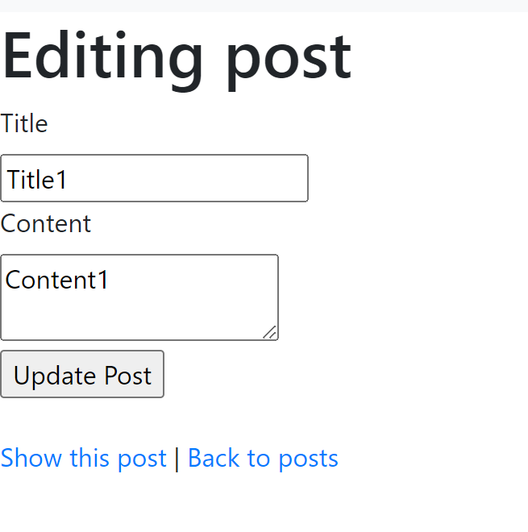

**7-1**

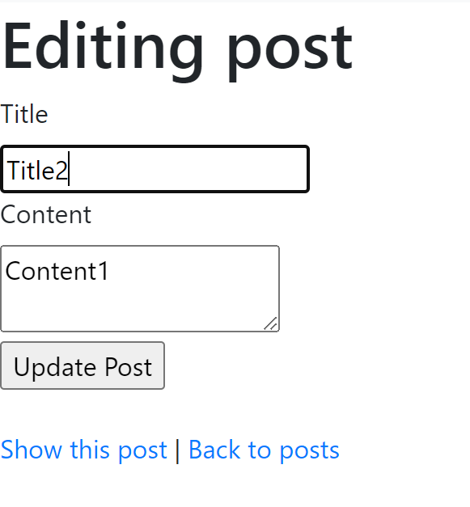

**7-2**

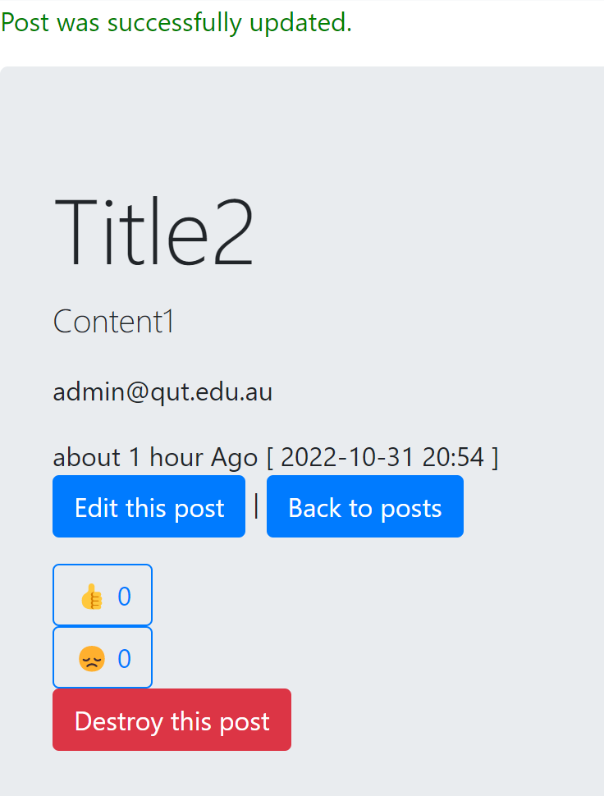

**7-3**

## View announcements

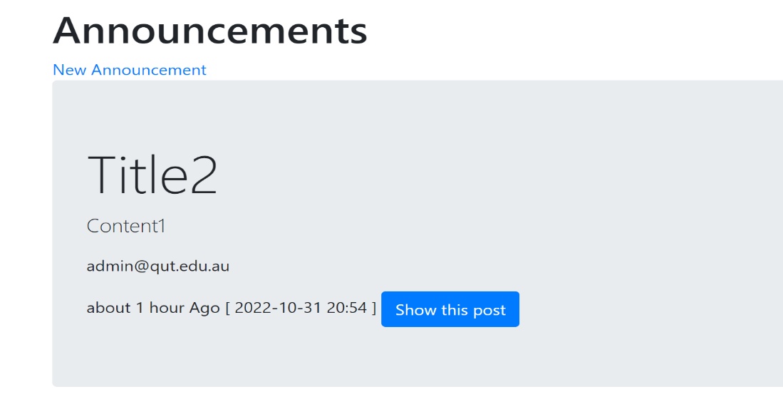

**8-1**

## Comment on announcements

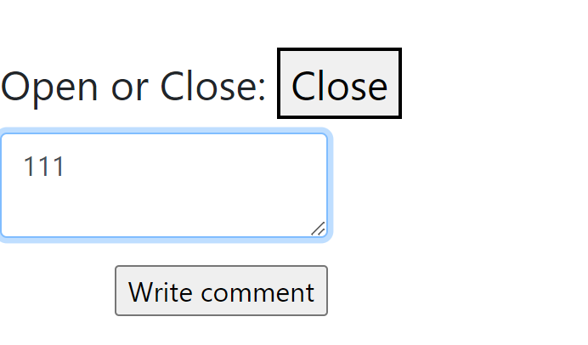

**9-1**

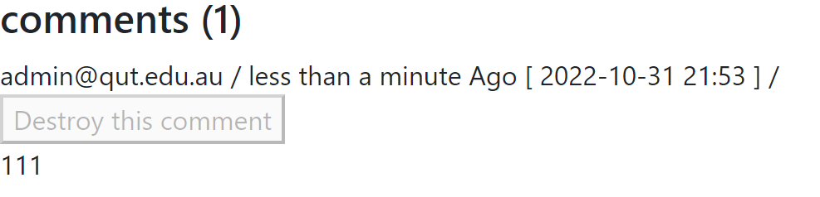

**9-2**

## React

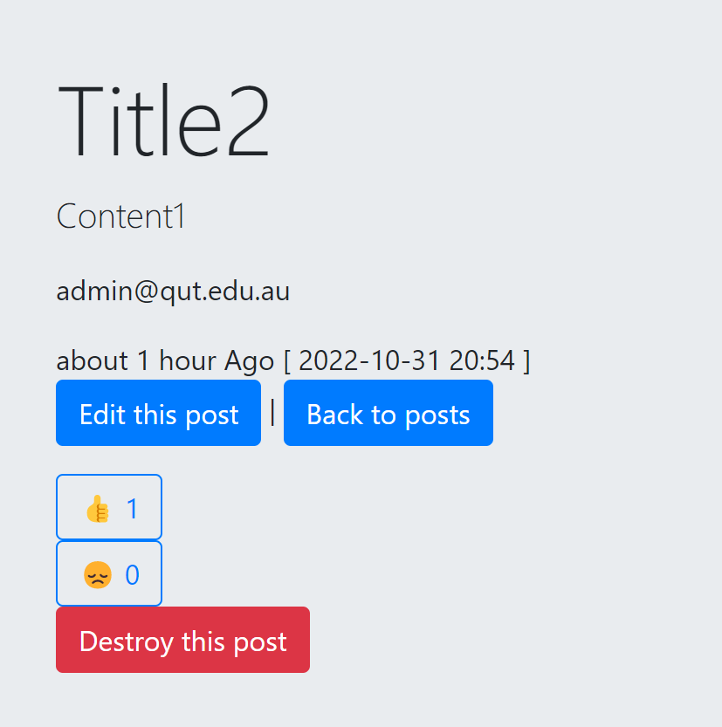

**10-1**

## View reactions



**11-1**

## Reply to other’s comments

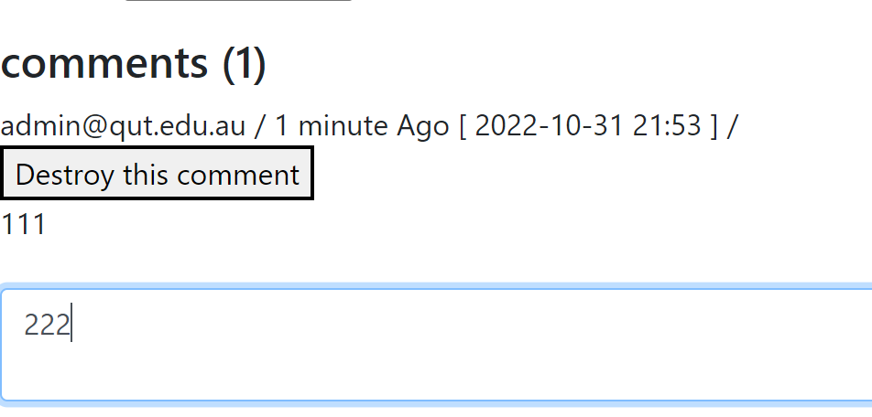

**12-1**

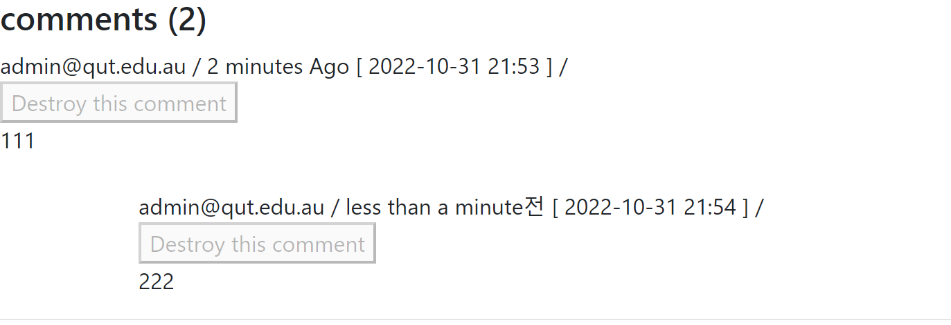

**12-2**

## Open/close session

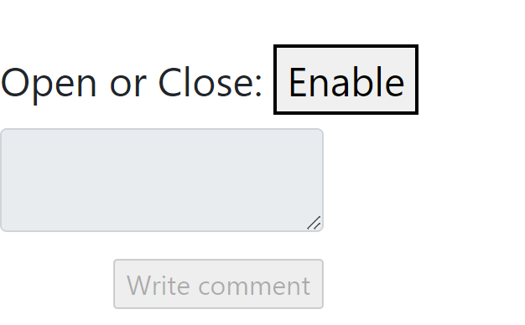

**13-1**

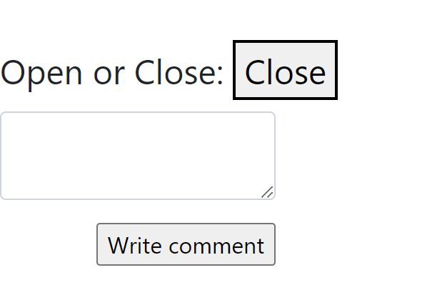

**13-2**